Portfolio website
Click on this link link to view my website
https://altruisticdream.github.io/
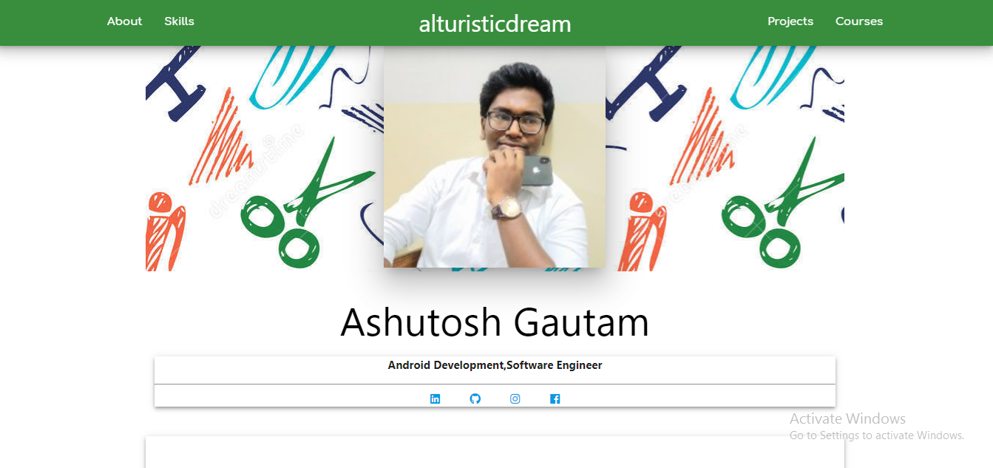

Contact me
ashutoshgautam9628@outlook.com

